Every production is a collaboration involving many, many people. While CATCO has from the beginning been “an actors’ theatre,” the company has also focused when it could on improving the design elements of its productions. Over the last 7 years or so, since moving to the Riffe Center completely, CATCO has been able to enhance the technical design elements tremendously. Below are the “deep thoughts” of several of CATCO’s designers for this production of The Complete History of America (Abridged).

Kate Robbins: Costume Designer

Part of the reason I have spent over 30 years as a theatre designer is the fact that every show is different; no two projects are ever alike. Even designing the same script multiple times is not boring because the production team, the design team and the cast are different each time. There is always a sense of anticipation, of excitement, as one begins each new project and, although there are some basic things I do for every project, such as read the script several times, each production requires a little bit different approach. I had seen CATCO's production of The Complete Works of Shakespeare (Abridged) and had thoroughly enjoyed it. So when TJ Gerckens, CATCO’s Production Manager, offered me the opportunity to design The Complete History of America (Abridged), I jumped at the chance.

For most projects, my design approach incorporates research of period style and the use of the design elements of line, mass, color, and texture to express character and assist in telling the story. This show, however, is more a revue than a classically constructed theatrical piece, which brings to the job unique demands and challenges. Although I did do research for this project, it was more for the purpose of facilitating conversation with the director and sharing ideas with the other members of the design team.

In approaching this production, one of my first considerations was the safety of the actors. The three actors play multiple characters and race back and forth at a breakneck pace in order to make costume changes. That being the case, the choice of shoes for them was extremely important. For Jon and Tod, it was essential that the shoes appear to be dress shoes, but they could not have hard soles, as they would be constantly slipping. My next consideration was the rapid pace of the show. It was a challenge to make sure that we had enough of a costume change to make the character transition clear to the audience, but not so much that it would slow the pace of the show. I also sought to realize the approach the director articulated - that the costume pieces should appear to be items the actors themselves could have located or created and assembled to tell the story.

In addition, since the actors get hit with everything from water to Bavarian crème pie, it was critical that the costumes be easy to maintain and be durable. Finally, I wanted the base costumes to express the individuality of each of the actors and the costume pieces to add to the sense of irreverence and silliness expressed in the script.

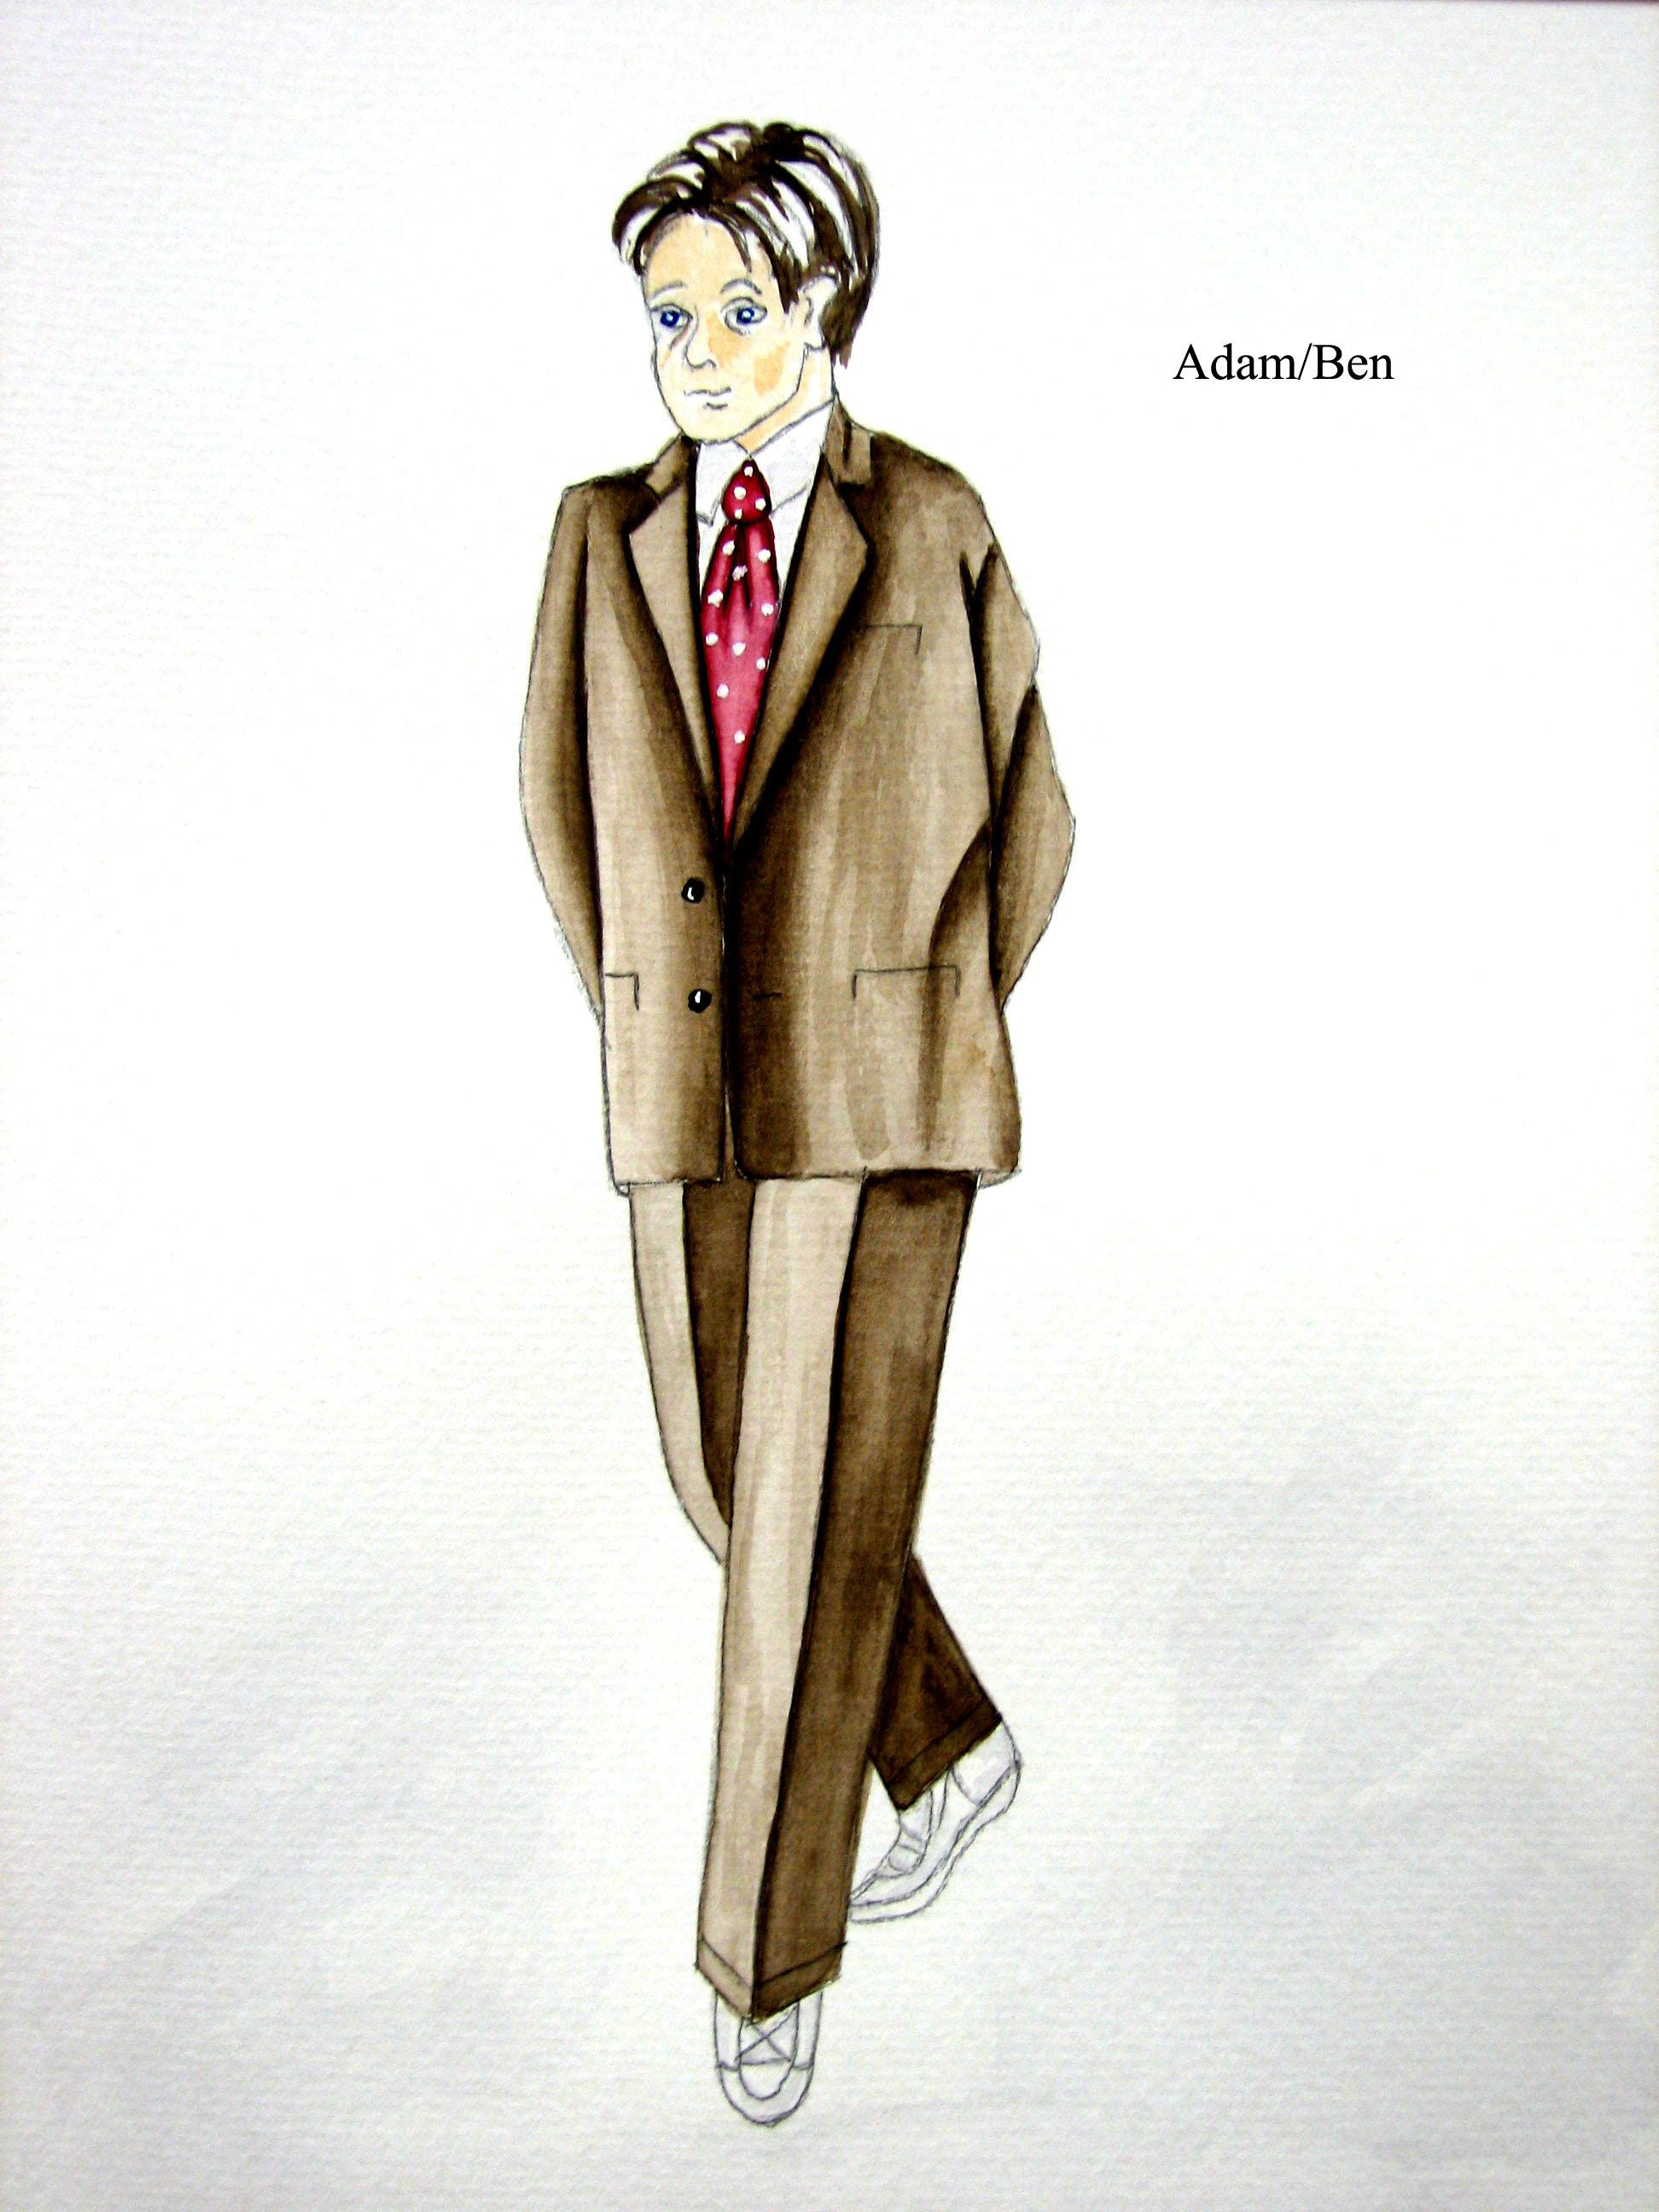

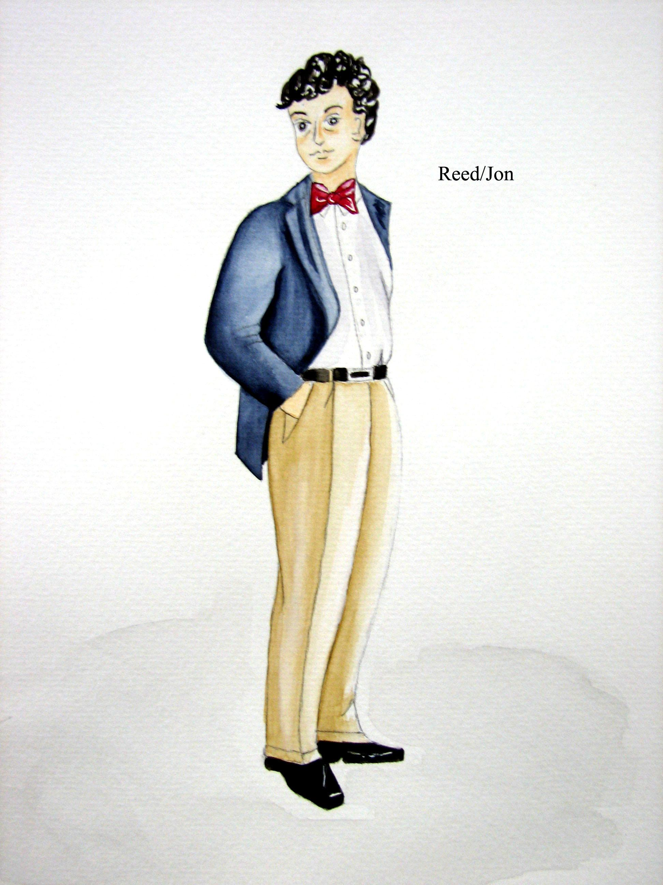
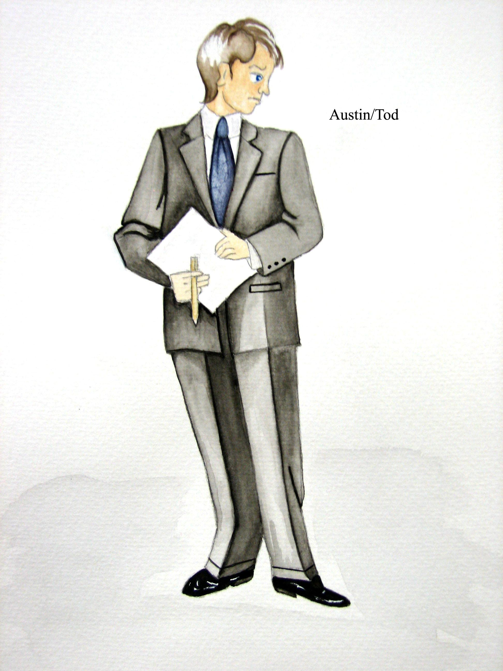

John Bohuslawsky: Lighting Designer

I've approached lighting this show in a way that allows me to stay open to whatever Geoff Nelson, the director, and the cast come up with. The nature of the play—it is a comedy—and the rehearsal/production schedule shaped this need for flexibility. Based on many readings of the script and a few discussions with the director and other participants, and having had some experience working with Geoff on this type of play in the past, I came up with a base plot which will allow me to cover all areas of the stage.

My base plot will allow me to cover every area of the stage with red, white and blue light (kinda patriotic don't you think?). In addition there are groups or systems of lights for specific tasks, monologues, and group scenes. Some lights are placed to illuminate (as well as affect) the scenery, some to help put the audience in a specific "place" (a foxhole, a radio show studio, a hallucination etc...), and some are quite literally dictated by the script (e.g., the slide show scene). I included "spares" in the plot for those unexpected moments that we'll find during the rehearsal process, especially the "cast run through" (a full-run of the play just before going into “tech week”). These "spares" are lights that I would like to attempt to use for specific moments. They may or may not work (based on new blocking or a change in the script because a joke was not working). If they work I'll say " hurray," if not, there's a plan "B" and even a plan "C" for each of them.

I also have reserved a number of units for the truly unexpected moments—moments that will not come out until all components (set, costume, props, actors) of the play come together in the theatre. These reserves are for the accidental moments and the suddenly inspired moments. They are there because I know they will be used; at this moment in time, I do not know how, but we'll know by opening night.

